CV

Personal Information
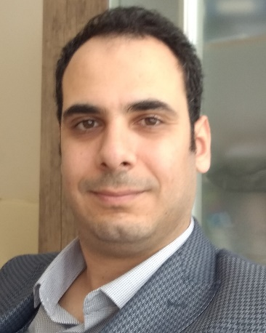
Surname, Name : AKKAYA, Sıtkı
Nationality : T.C.
Date of birth : 25.05.1987
Marital Status : Married & have 1 son
e-mail : stk.akkaya@gmail.com

Education

Degree  PhD | Unit  Gazi University / Elct. ve Electro. Eng. | Date  2013 - 2018
MS | Erciyes University / Elct. ve Electro. Eng. | 2009 - 2012
BSc | Erciyes University / Elct. ve Electro. Eng. | 2005 - 2009
High School | TED Kayseri College (Scholarship-3rd) | 2001 - 2005

Experiences
Title  Res. Ass. | Institution  Bozok University / Elct. ve Electro. Eng. | Date  2009 - 2018
Res. Ass. Dr. | Bozok University / Elct. ve Electro. Eng. | 2018 -2020
Ast. Prof. Dr. | Sivas Sci. & Tec. Uni./ Aircraft technology | 2020-

Theses
Master

Hybrid ARQ Systems Used in Wireless Communication

PhD*

Enhancement of the Methods Sensitive to Low & High - Frequency Interharmonics and Robust to Fundamental Frequency Deviations tor the Calculation of the Light Flicker

*( In the thesis, the data obtained from the busbars of the transformers feeding the electric arc furnaces within the scope of the National Power Quality Project were used.)

Language
English (YÖK-Dil 93.75)

Publications
International
SCI, SCI-Expanded indexed Journals
1. Akkaya S., Salor Ö., “Enhanced Spectral Decomposition Method for Light Flicker Evaluation of Incandescent Lamps Caused by Electric Arc Furnaces”, Journal of the Faculty of Engineering and Architecture of Gazi University, accepted on 23rd May 2018, doi: 10.17341/gazimmfd.460497.

2. Akkaya S., Salor Ö., “A New Flicker Detection Method for New Generation Lamps Both Robust to Fundamental Frequency Deviation and Based on the Whole Voltage Frequency Spectrum”, MDPI-Electronics, 7(6), 99, 15 June 2018, doi:10.3390/electronics7060099.

3. Akkaya S., Salor Ö., “New Flickermeter Sensitive to High-Frequency Interharmonics and Robust to Fundamental Frequency Deviations of the Power System”, IET Science, Measurement & Technology, 25 July 2019, DOI: 10.1049/iet-smt.2018.5338.

Papers Presented in the Conferences & Congeresses

International
1. Taşpınar N. and Akkaya S., "Generalized Type- II Hybrid SR-ARQ Scheme Using Punctured Convolutional Coding and Code Combining Technique in Multi- Carrier Code Division Multiple Access ( MC-CDMA) Systems”, Proceding of Elektro 2012 Conference, Slovakia, pp 378-381 (2012).

2. Akkaya S. and Taşpınar N., "Generalized Type- II Hybrid SR ARQ Scheme Using Punctured Convolutional Coding and Code Combining Technique in Wavelet Packet Division Multiplexing (WPDM)”, Proceding of 2. World Conference on Information Technology (WCIT), Antalya, Procedia Computer Science, ID:8775, sequence number: 423,(2011).

3. Akkaya S. and Taşpınar N., “Dikgen Frekans Bölmeli Çoğullama (OFDM) Sistemlerinde Konvolüsyon Kodlarını Kullanan II. Türden Kod Birleştirmeli Karma SR ARQ Protokolü”, 6th International Advanced Technologies Symposium (IATS’11), Elazığ, pp: 376-381. (2011).

Awards

1. ULAKBİM Publication Incentive Award: Akkaya S., Salor Ö., “Enhanced Spectral Decomposition Method for Light Flicker Evaluation of Incandescent Lamps Caused by Electric Arc Furnaces”, Journal of the Faculty of Engineering and Architecture of Gazi University, accepted on 23rd May 2018, DOI: 10.17341/gazimmfd.460497.

2. ULAKBİM Publication Incentive Award: Akkaya S., Salor Ö., “New Flickermeter Sensitive to High-Frequency Interharmonics and Robust to Fundamental Frequency Deviations of the Power System”, IET Science, Measurement & Technology, 25 July 2019, DOI: 10.1049/iet-smt.2018.5338.

Reviewer in

1. Electric Power Components and Systems.

2. IET Science, Measurement & Technology.

3. American Journal of Electrical Power and Energy Systems .

4. IET Generation, Transmission & Distribution

Projects
1. Researcher, Erciyes University, Thesis Project, Master, FBY-10-3384, Hybrid ARQ Systems Used in Wireless Communication, completed (2012).

2.Adviser, TUBITAK 2209-A University Students Research Projects Support Program, Adjusting the Position of Products from Conveyor Band, Application no: 1919B011904317, completed (2020).

Lessons in the last two years
- Mathematics 1
- Engineering Mathematics 1
- Mathematics 2
- Engineering Mathematics 2
- Digital Communication
- Artificial neural networks
- Electric-Electronic Design and Application
- Final project
- Computer Aided Design (AUTOCAD)

